Would you know what to do if someone collapsed?
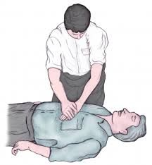
The Parish Council is providing two defibrillator devices for the village
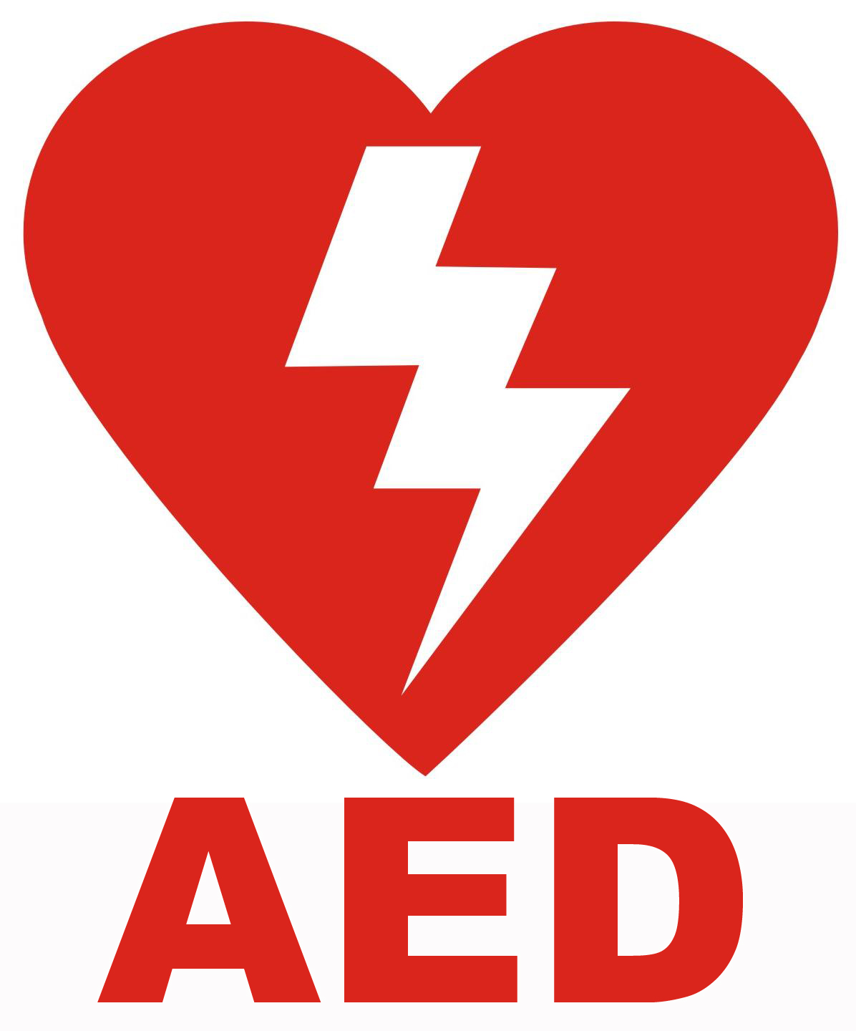
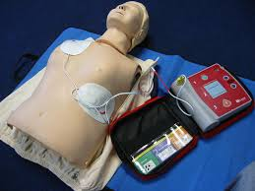

If you are interested in attending a short free training session to learn how to use them please contact:

Liz Butterworth, Clerk to the Parish Council
Lizbutterworth1@btinternet.com / 01789 268998

