PARISH OF WILMCOTE

NOTICE OF ORDINARY PARISH COUNCIL MEETING FOLLOWING THE ANNUAL MEETING

Dated this 22nd day of January 2021
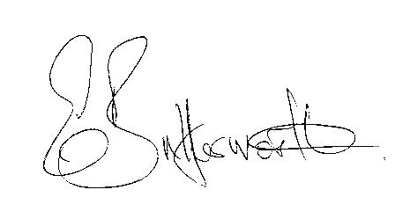Clerk to the Parish Council

BUSINESS TO BE TRANSACTED

- Record of Members Present.

- To receive apologies and approve reasons for absence.

- P.C. Rob Davies, Neighbourhood Police Constable, for general discussion in relation to any police related questions.

- To receive written requests for Disclosable Pecuniary Interests.

- To approve for signature the minutes of the Parish Council meeting held on 18th November 2020.

- Public participation:

7. Correspondence: All correspondence sent electronically to date will be taken as
read.

8. County and District Councillor reports.

9. Planning applications – status of current applications.
20/02670/FUL Hill House, Birmingham Road, Pathlow: Amendment notification.

10. Final agreed Precept request (C.R.)

11. S137 grant applications proposed amendment (K.S.)

12. Consultation: Gypsy and Traveller and Travelling Showpeople sites (W.S.)

13. Road traffic items.
a. Church Road safety (W.S.)

14. Willow Wood playground: Consideration of equipment to replace the recently removed items (J.L.)

15. Review of Financial regulations. Review team

16. Review of Emergency Plan. (G.S.)

17. Training in use of Defibrillator. (G.S.)

18. Environmental initiatives. (W.S.)

19. Items for the agenda for the next meeting.

20. Date of next meeting 17th March 2021.

