**NOTICE OF EXTRAORDINARY MEETING**

**OF WILMCOTE PARISH COUNCIL**

A meeting of the Parish Council will be held in Wilmcote Village Hall on the 25th February 2025 at 7.15 p.m.

### **BUSINESS TO BE TRANSACTED**

1. Present.
2. Apologies for absence.
3. Declarations of interests in the SWLP Preferred Options Consultation
4. To agree and vote on the parish council response to the

Preferred Options Consultation

Members of the public and press are welcome.

Dated this 20th day of February 2025

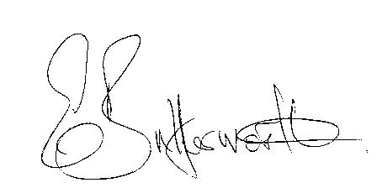Clerk