**PARISH OF WILMCOTE**

**A meeting of the Parish Council for the above named Parish will be held at 7.30pm in Wilmcote Village Hall on 22nd January 2025.**

Dated this 18th day of January 2025

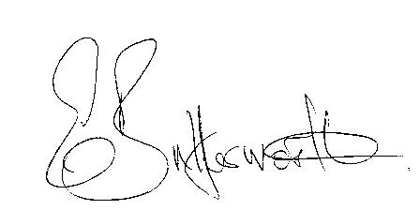Clerk to the Parish Council

**BUSINESS TO BE TRANSACTED**

1. Record of Members present.

2. To receive apologies and approve reasons for absence.

3. To receive written requests for Disclosable Pecuniary interests in items on

the agenda.

4. Public Participation

5. To approve for signature the minutes of the Parish Council meeting

held on 20th November 2024.

6. County and District Councillor reports.

7. Correspondence received and previously circulated will be taken as read.

8. Status of current planning applications.

9. Precept request for 2025/26

10. Barn construction at New House Farm, Pathlow update.

11. South Warwickshire Local Plan consultation.

12. Pathlow Park Traveller Site update.

13. Subsidence adjacent to the railway bridge update

14. Community Speedwatch update

15. New Domain names and new Cllr. and Clerk Email addresses update

16. Willow Wood Playground report.

17. Mary Arden Inn update

17. Councillors’ reports on items not on the agenda.

18. Items for the agenda for the next meeting.

19. Mary Arden’s Farm

20. Date of next meeting 19th March 2025. Annual Parish Assembly followed by

an ordinary Parish Council meeting