PARISH OF WILMCOTE

A meeting of the Parish Council for the above named Parish will be held at 7.30pm in Wilmcote Village Hall on 20th March 2024 following the Annual Parish Assembly.

Dated this 15th day of March 2024
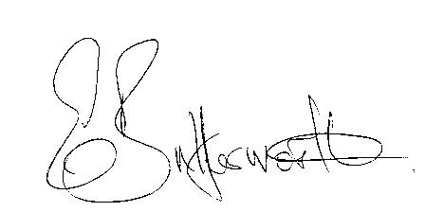Clerk to the Parish Council

BUSINESS TO BE TRANSACTED

1. Record of Members present.

2. To receive apologies and approve reasons for absence.

3. To receive written requests for Disclosable Pecuniary interests in items on
the agenda.

4. Sarah Brooke-Taylor, WRCC Housing Enabler to discuss the possibility of a new
survey being carried out as the previous one undertaken in 2015 is now out of
date.

5. To consider a request from Ms. S Hession to be co-opted onto the council.

6. To approve for signature the minutes of the Parish Council meeting
held on 24th January 2024.

7. Public participation.

8. County and District Councillor reports.

9. Status of current planning applications.
Consider DISCN/00107/24 Garages Glebe Estate, Wilmcote.

10. Correspondence received and previously circulated will be taken as read.

11. Mary Arden Inn update.

12. Willow Wood Play Area update.

13. Warwickshire Rights of Way Improvement Plan Survey questionnaire:Cllrs Ray and Stewart completed and returned the relevant survey questionnaire having gained approval from other Councillors.

14. Parish Council Grant Fund applications 2024/2025

15. Community Speedwatch update.

16. Lead Councillors: to verify responsibilities.

18. Councillors’ reports on items not on the agenda.

19. Items for the agenda for the next meeting.

20. Date of next meeting: 15th May 2024. Annual Parish Council meeting followed by
an ordinary parish council meeting.

