**PARISH OF WILMCOTE**

**A meeting of the Parish Council for the above named Parish will be held at 7.30pm in Wilmcote Village Hall on 19th March 2025 following the Annual Parish Assembly.**

Dated this 15th day of March 2025

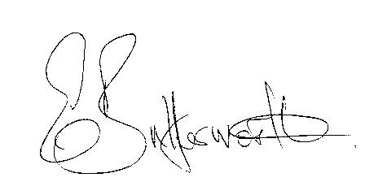Clerk to the Parish Council

**BUSINESS TO BE TRANSACTED**

1. Record of Members present.

2. To receive apologies and approve reasons for absence.

3. Declaration of Disclosable Pecuniary interests in items on the agenda.

4. To approve for signature the minutes of the Parish Council meeting

held on 22nd January 2025 and Extraordinary meeting on 25th February 2025.

5. Public participation.

6. County and District Councillor reports

7. Status of current planning applications.

8. Correspondence received and previously circulated will be taken as read.

9. Mary Arden’s House update.

10. Willow Wood Play Area update.

11. Parish Council Grant Fund applications 2025/2026.

12. Community Speedwatch update.

13. Matters arising since the Extraordinary meeting on 25th February.

14. Items for the agenda for the next meeting.

15. Date of next meeting 21st May Annual Parish Council meeting followed by an

ordinary parish council meeting.