**PARISH OF WILMCOTE**

**A meeting of the Parish Council for the above named Parish will be held at 7.30pm in Wilmcote Village Hall on 18th SEPTEMBER 2024.**

Dated this 13th day of September 2024

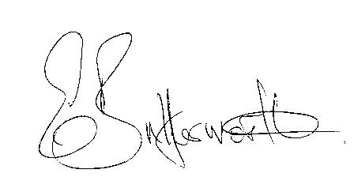Clerk to the Parish Council

**BUSINESS TO BE TRANSACTED**

1. Record of Members present.

2. To receive apologies and approve reasons for absence.

3. To receive written requests for Disclosable Pecuniary interests in items on

the agenda.

4. Barn construction at New House Farm in Pathlow.

5. Public Participation

6. To approve for signature the minutes of the Parish Council meeting

held on 17th July 2024.

7. County and District Councillor reports.

8. Correspondence received and previously circulated will be taken as read.

9. Status of current planning applications.

10. Willow Wood Playground progress report.

11. Community Speed Watch – to consider purchase of a new speed device

12. Pathlow Park Traveller Site

13. Subsidence adjacent to the railway bridge.

14. Mary Arden Inn hedge.

15. New Domain names and new Cllr. and Clerk Email addresses.

16. Clerk – Employment contract.

17. Councillors’ reports on items not on the agenda.

18. Items for the agenda for the next meeting.

19. Date of next meeting: 20th November 2024