PARISH OF WILMCOTE

A meeting of the Parish Council for the above named Parish will be held at 7.30pm in Wilmcote Village Hall on 17th July 2024.

Dated this 12th day of July 2024
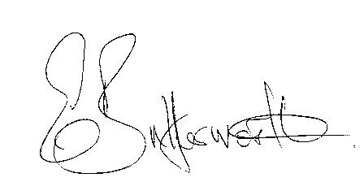Clerk to the Parish Council

BUSINESS TO BE TRANSACTED

1. Record of Members present.

2. To receive apologies and approve reasons for absence.

3. To receive written requests for Disclosable Pecuniary interests in items on
the agenda.

4. Gary Strain, Warwickshire Police Road Safety Officer and Sally Rolfe BA of the road safety unit - Traffic Management Advisor Warwickshire Police to provide a demonstration of the Bushnell speed device and talk about reactivating Community Speedwatch Groups in the area.

5. Public Participation

6. To approve for signature the minutes of the Annual Parish Council meeting
and ordinary meeting held on 15th May2024.

7. County and District Councillor reports.

8. Correspondence received and previously circulated will be taken as read.

9. Status of current planning applications.
Consideration of Planning Application No. 24/01381/FUL Sunny Bank Wharf Lane, Wilmcote: Demolition of existing dormer bungalow and construction of replacement dwelling (Self-build).

10. Willow Wood Playground progress report.

11. WRCC Housing Survey report.

12. Wilmcote PC Grant Fund – revised for website and dates for next applications.

13. Subsidence adjacent to the railway bridge.

14. Councillors’ reports on items not on the agenda.

15. Items for the agenda for the next meeting.

16. Date of next meeting: 18th September 2024

