PARISH OF WILMCOTE

A meeting of the Parish Council for the above named Parish will be held at Wilmcote Village Hall on 15th May 2024 at 7.30pm

Dated this 10th day of May 2024
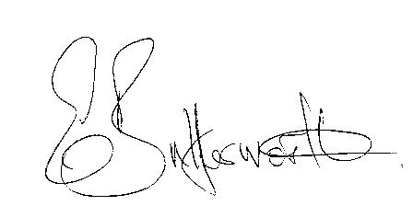Clerk to the Parish Council

WILMCOTE PARISH COUNCIL ANNUAL MEETING

AGENDA

Election of Chairman
Record of members present
Apologies for Absence
To receive the Chairman’s Declaration of Acceptance of Office
Declarations of Interests in items on the agenda
Election of Vice Chairman if required
Appointment of Internal Auditor
Statement of Finances as at 31st March 2024
Approve following standard items included in Precept for payment:

HMRC PAYE & NI - Quarterly
Clerk’s salary - monthly
WALC subs – annual
SDC Website hosting – annual
Npower energy
E.on maintenance
Zurich Insurance - annual
G. Compton for grass cutting – The Green
Auditors - internal and external – annual
S137 grants once agreed by Cllrs - annual
ICO annual
CPRE annual

PLAYGROUND
Gary Compton – grass and hedge cutting plus litter picking
SDC Lease 6 monthly
Monthly inspections
Annual inspection

Followed by

ORDINARY PARISH COUNCIL MEETING

- To receive written requests for Disclosable Pecuniary Interests.

- To approve for signature the minutes of the Extraordinary meeting held on 28th February 2024, Annual Parish Assembly meeting and ordinary meeting held on 20th March 2024.

- Public participation.

- County & District Councillor’s reports.

- Annual Accounts of Wilmcote Parish Council for 2023/20234.
a) Annual Governance statement.
b) Accounting Statements.

- Planning Applications – the current status of planning applications
was circulated to Cllrs prior to the meeting.

To consider an application for a Street Trading Consent in the Stratford on Avon area zone 3.

- Correspondence received and previously circulated will be taken as read.

- Willow Wood Play Area update.

9. Footway Lighting update.

10. Wilmcote Parish Council Grant Fund application.

11. Pathlow Park Traveller Site update.

12. WRCC proposed Housing survey update.

13. Wilmcote Parish Council Facebook page: Cllr Hession launched this
on 10th April. There are 69 followers since the launch. The page promoted a survey and the local police team published the result, being three priorities for additional speed checks in Wilmcote.

14. WALC items: a) New model financial regulations
b) PC Domain names and new email addresses

15. Councillors reports and items for the agenda for the next meeting.

16. Date of next meeting: 17th July 2024.

